Infosys HotelRevAi Documentation
Ai Driven Revenue Analysis for Hotels
Abstract
This project focuses on analyzing hotel booking and revenue data to uncover trends, optimize pricing strategies, and improve overall profitability. The dataset captures multiple factors such as customer type, room rate, booking channel, region, and customer satisfaction. Using Power BI dashboards, key performance metrics such as total revenue, total profit, occupancy rate, and profit margin were visualized to support data-driven decision-making. The analysis enables hotel managers to understand customer preferences, monitor regional performance, and adopt dynamic pricing for better revenue outcomes.
Problem Statement
Hotels face multiple challenges in managing their operations and maximizing revenue due to:
- Dynamic pricing optimization challenges
- Inaccurate demand forecasting
- Competitor benchmarking difficulties
- Seasonal fluctuations
- Balancing occupancy and profitability
This project aims to analyze key data points to address these challenges through visualization and performance tracking.
Objectives
- To identify major revenue drivers across regions, hotel types, and room types
- To analyze occupancy and pricing patterns over time
- To understand the impact of customer demographics on profitability
- To create interactive dashboards for effective decision-making
- To suggest strategies for improving forecasting accuracy and pricing flexibility

1. Dataset Overview
This dataset contains detailed information about hotel bookings collected across multiple properties and regions. It includes customer details, booking characteristics, service usage, and financial metrics. The dataset is designed to support analysis, visualization, and prediction tasks such as revenue trends, occupancy analysis, customer behavior insights, and profitability tracking. The dataset consists of approximately 2,000+ records and 33 columns, covering the entire booking-to-checkout journey.

2. Column Descriptions
Column Name | Description | Data Type
Booking ID | Unique identifier for each booking | Text/String
Hotel Name | Name of the hotel where the booking occurred | Text/String
Hotel Type | Type of hotel (Luxury, Budget, Boutique, etc.) | Text/String
Region | Geographical region of the hotel | Text/String
Country | Country where the hotel is located | Text/String
Booking Date | Date on which the booking was made | Date
Check-in Date | Date of arrival at the hotel | Date
Check-out Date | Date of departure from the hotel | Date
Room Type | Type of room booked (Deluxe, Suite, Family, etc.) | Text/String
Customer Type | Type of customer | Text/String
Booking Channel | Mode used for booking | Text/String
Payment Mode | Method of payment used | Text/String
Rooms Available | Total number of rooms available at the hotel | Integer
Rooms Booked | Number of rooms booked by the customer | Integer
Nights Stayed | Number of nights the customer stayed | Integer
Room Rate | Price per night per room | Decimal (₹)
Total Cost | Overall cost of the booking, including services | Decimal (₹)
Customer Age | Age of the primary customer | Integer
Customer Gender | Gender of the customer | Text/String
Customer Satisfaction Score (out of 10) | Rating given by customer post stay | Integer
Meals Included | Whether meals were included in booking | Yes/No
Spa Used | Whether spa services were used | Yes/No
Gym Used | Whether gym services were used | Yes/No
Parking Used | Whether parking was used | Yes/No
Laundry Used | Whether laundry service was used | Yes/No
Transport Service | Whether transport service was used | Yes/No
Discount Percentage | Discount applied on total booking | Decimal (%)
Tax Amount | Total tax charged | Decimal (₹)
Cancellation Status | Indicates if booking was cancelled or confirmed | Text/String
Special Request | Notes on customer requests (e.g., late check-in, sea view) | Yes/No
Total Revenue | Final revenue earned after discounts and taxes | Decimal (₹)
Profit | Profit earned from the booking | Decimal (₹)
Profit Margin | Profit percentage of total revenue | Decimal (%)

3. Key Calculations
- Total Cost: (Room Rate × Nights Stayed × Rooms Booked) + Extra Services (SPA + Meals + Transport + Laundry, etc.)
- Total Revenue: Total Cost - (Discount Percentage of Total Cost) + Tax Amount
- Profit: Total Revenue – Total Cost
- Profit Margin: (Profit / Total Revenue) × 100

Dashboard 1 – Hotel Revenue Analysis
- The Hotel Revenue Analysis Dashboard was created using Microsoft Power BI to visually represent insights from the hotel booking dataset.
It helps in understanding overall business performance, profitability, and regional trends.
Purpose
- The main goal of this dashboard is to monitor revenue, profit, and customer metrics in an interactive and easy-to-understand format, supporting decision-making for hotel management.
Key Insights Displayed
- Total Profit:
Shows the overall profit generated across all hotels.
- Profit Margin:
Displays the cumulative profit margin percentage across bookings.
- Total Revenue Gauge:
A semi-donut visual that highlights the overall revenue achieved compared to the target.
- Revenue by Region:
A pie chart that breaks down total revenue contribution by region — South, North, East, West, and Central.
- Total Revenue by Hotel Type:
A bar chart comparing hotel categories such as Luxury, Business, Budget, and Boutique, showing which types perform best financially.
- Total Revenue by Booking Date:
A line chart showing revenue trends over time, helping to identify high and low booking periods for better planning.
- Dynamic filters for Hotel Name, Region, and Customer Type.
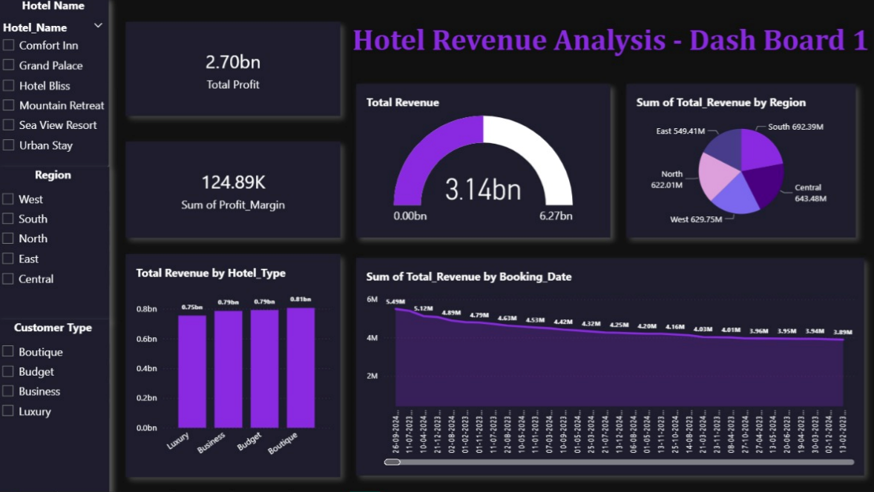
Dashboard 2 – Customer and Channel Insights
- The Dashboard 2 focuses on analyzing customer demographics, booking channels, and profitability patterns. It provides an in-depth understanding of customer behavior and the most effective sales channels.
Purpose
- To evaluate how different customer types, age groups, and booking methods contribute to the hotel's overall revenue and profitability.
Key Insights Displayed
- Average Occupancy Rate:
Displays the average occupancy percentage across all hotels.
Example: 22.15%
- Total Revenue by Booking Channel:
A bar chart comparing revenue generated from each channel —
Corporate Booking, Travel Agent, Offline, and Online.
Example: Corporate Booking contributed 97M.
- Total Revenue by Customer Type:
A pie chart dividing total revenue by types of customers —
Corporate, Returning, Group, and New Customers.
- Sum of Rooms Booked by Booking Date:
A line/column chart that tracks the number of rooms booked over time, showing peak booking periods.
- Profit Margin by Customer Age:
A bar graph illustrating how profit margin varies by customer age group.
- Filters for Region, Customer Type, and Booking Channel
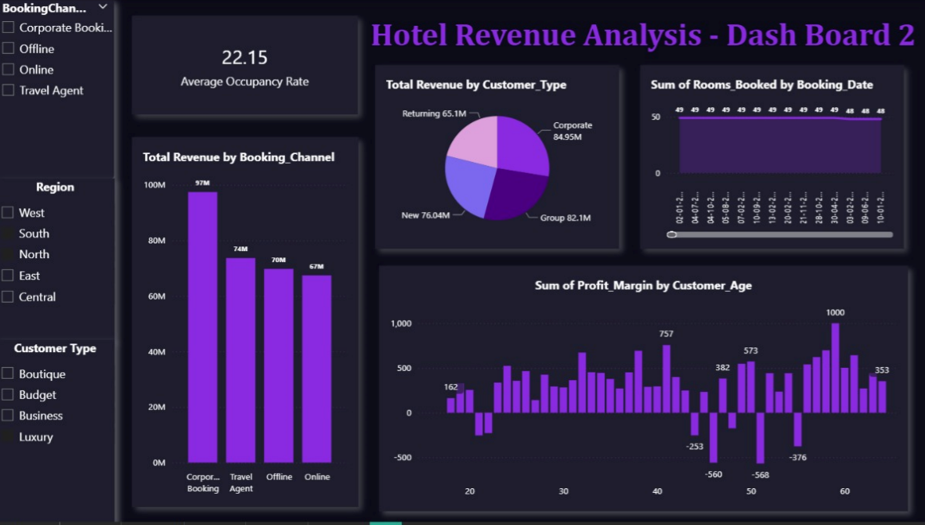
Dashboard 3– Room Type and Pricing Insights
- The Dashboard 3 focuses on analyzing revenue and occupancy based on room types, providing valuable insights into pricing strategy, booking preferences, and profitability.
Purpose
- To identify the most profitable and popular room types, analyze occupancy rates, and understand how room rates affect total profit and revenue over time.
Key Insights Displayed
- Highest Room Rate:
Displays the maximum room rate recorded in the dataset.
- Most Booked Room Type:
Highlights the room category with the highest number of bookings.
- Occupancy Rate by Room Type:
A horizontal bar chart showing occupancy levels across various room types —Family, Suite, Double, Single, and Deluxe.
Helps identify which room types are most in demand.
- Total Revenue by Room Type:
A bar chart comparing total revenue generated by each room category, showing their contribution to overall hotel performance.
- Room Rate, Profit, and Revenue Over Time:
A scatter plot visualizing how Room Rate, Total Profit, and Total Revenue vary by Booking Date.
It highlights patterns and helps determine optimal pricing ranges.
- Filters for Hotel Name, Region, and Hotel Type
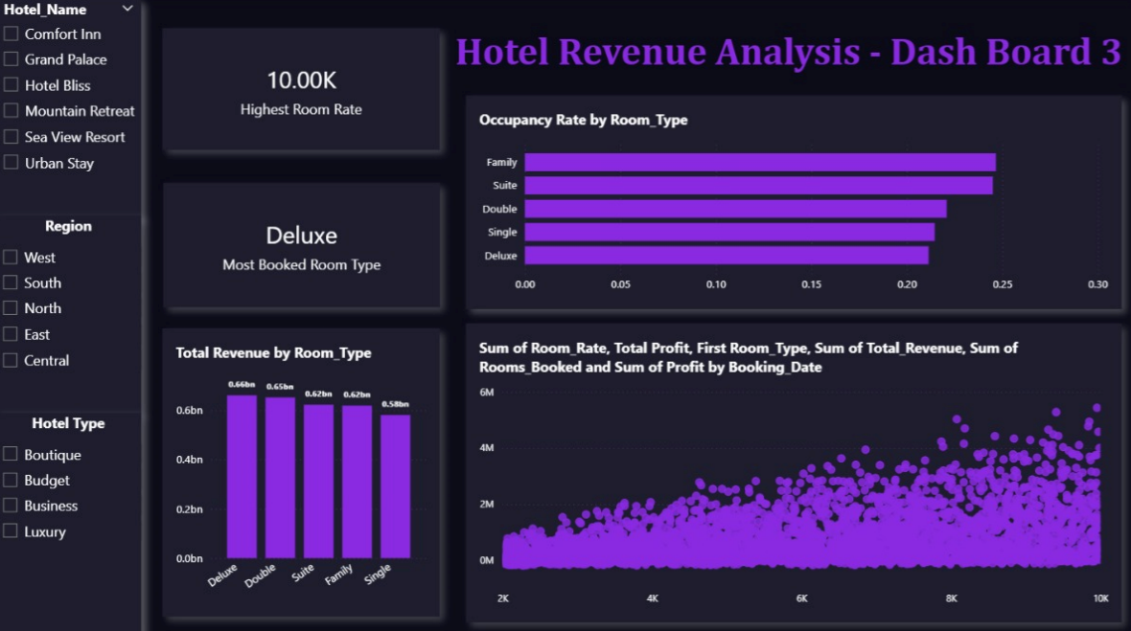
Dashboard 4: Hotel Revenue Analysis
- This dashboard provides an in-depth analysis of hotel profitability and cost distribution across multiple dimensions. It focuses on understanding overall revenue performance, regional profit variations, and cost efficiency among different hotels.
Purpose
To evaluate and compare the financial performance of different hotels, identify the most profitable regions, and monitor profit trends over time to support data-driven decision-making in hotel management.
Key Insights Displayed
- Total Profit:
The total profit across all hotels amounts to 2.70 billion.
- Profit Margin (%):
Displays the cumulative profit margin of all hotels combined.
- Profit Distribution by Region:
A pie chart visualizes profit contribution from each region (East, West, North, South, and Central), highlighting the top-performing areas.
- Hotel Profit Summary:
A detailed table comparing each hotel’s total cost, total revenue, and overall profitability.
- Revenue vs Cost by Hotel:
A horizontal bar chart illustrating how total revenue compares with total cost for each hotel, helping identify cost-efficient operations.
- Profit Trend Over Time:
A line chart showing profit fluctuations over a given period, useful for tracking financial stability and seasonality effects.
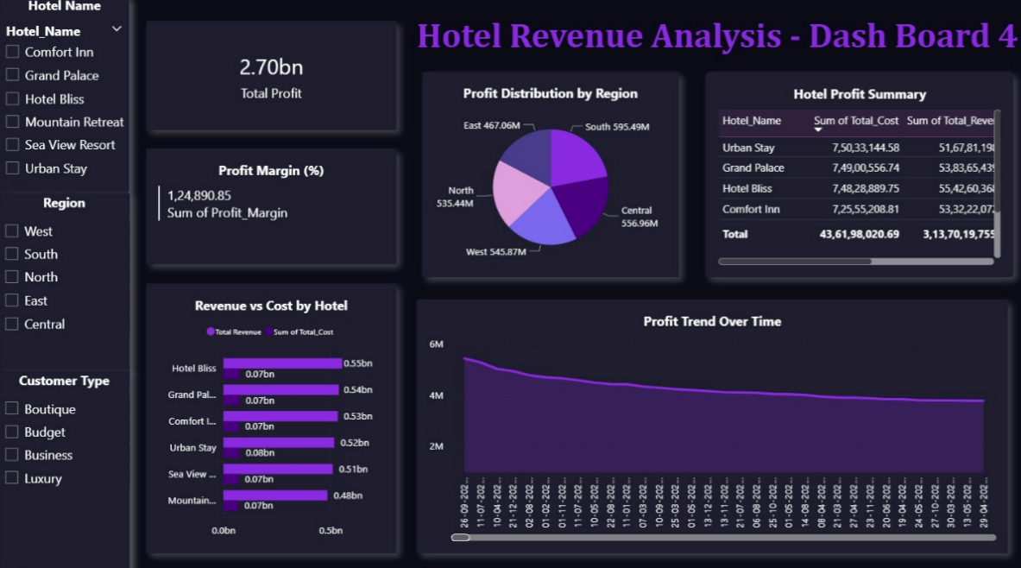
Insights and Findings
- Boutique and Budget hotels generate the highest revenue.
- Corporate booking channels contribute the most to total revenue, followed by travel agents.
- The Deluxe room type has the highest booking frequency.
- The South and North regions show consistently strong revenue performance.
- The Corporate customer type accounts for a larger share of the total revenue.

Conclusion
- This analysis provides a comprehensive understanding of hotel performance metrics, allowing data-driven business strategies. The dashboards help management evaluate profitability, occupancy, and customer behaviour effectively. By leveraging these insights, hotels can improve demand forecasting, optimize pricing models, and maintain an ideal balance between occupancy and profit. The study emphasizes the importance of data analytics in enhancing the operational and financial efficiency of the hospitality industry.

Team Details
- Pon Madhumitha A
- Ankush Kumar Singh
- Namita Annappa Naik
- Karri Sripathirao
- Varsha Natrajan
- Apurva Hippargi
- Dogiparti N V K Meenakshi

